**Methods and Initial Results**

MACS 30200, Tong Ju

May. 17 2017

**Authoritarian Discourses of China during Social Movements in the 1980s**

As noted in the section of [Literature Review](https://github.com/jtbeyond/MACS30200proj/blob/master/LitReview/Literature%20Review-%20Tong%20Ju.pdf), this project studies how discourses of Chinese authoritarian government change in response to two emerging social movements in China during the 1980s, the 1986 Student Demonstration and the Tiananmen Square Protest in 1989. The 1986 Student Demonstrations took place in a number of Chinese cities from December 1986 until early January 1987. The demonstrations started in the city of Hefei in Anhui Province before spreading to other cities such as Shanghai and Nanjing. The movement participants were critical of the Chinese government’s lack of political reforms. Street demonstrations started to occur in early December, but quickly dissipated under military repression of the state by early January before achieving any of its stated goals (for more details about this movement, please see [here](https://en.wikipedia.org/wiki/1986_Chinese_Student_Demonstrations)). The Tiananmen Square Protests in 1989 were also student-led demonstrations in Beijing in 1989. The movement arose from societal members’ dissatisfaction with government’s lack of political reforms as well, but it grew into large-scale protests across the country in April and May 1989, involving millions of people. The protests were forcibly suppressed after the government declared martial law in early June. In what became widely known as the Tiananmen Square Massacre, troops with assault rifles and tanks killed at least several hundred demonstrators trying to block the military’s advance towards Tiananmen Square (for more details about this movement, please see [here](https://en.wikipedia.org/wiki/Tiananmen_Square_protests_of_1989)).

As previous researchers have pointed out, the *People’s Daily*, the mouth-piece of the Chinese Communist Party (CCP) does offer us opportunities to investigate the official discourses of the autorotation state during the late 1980s for two reasons (Frank, 1990; Wu, 1994). First, *People’s Daily* is published worldwide with a circulation of 3 to 4 million, and thus is the most influential official newspaper of the Chinese government. Second, the CCP always signals its attitudes toward certain social and political issues through this paper. For example, during the Tiananmen student pro-democracy movement, the government published the notorious editorial “Firmly Stand Against the Counter-revolutionary Turmoil” on April 26th of 1989 to intimidate the participants of the movement. Also, after the crackdown of the Tiananmen movement, series of news reports and editorials on the *People’s Daily* were meticulously framed to construct a counter-traumatic narrative of the massacre, and to attack the student leaders and intellectual elites as “a small handful of people” who intend to overturn the Socialist institutions.

Since there is no ready-to-use text corpus of People’s Daily available on-line, I scrape the raw texts from this electronic resource (<http://www.ziliaoku.org/rmrb)> by R programming. As for the dataset of this project, I collect all reports in the front page of People’s Daily, the official newspaper of the Chinese Communist Party, between January 1, 1986 to December 31, 1990. This dataset includes 1,826 pages of article reports over five years, which is appropriate for the study of official discourses before and after the key movements. To segmentize and tokenize the Chinese texts, the specific R package, *Jieba*, was subsequently used, and particular non-substantive words, namely the “stop words” were removed from each news report following the general procedures widely applied in the literatures (He *et al*, 2014). After tokenization, the text corpuses of the same individual days were combined together to constitute a new corpus under that date. Then, each date’s corpus was vectorized by using package *Jieba*, to offer a large tidy data frame with dates as columns, and individual substantive terms as rows. By using this dataset that includes 212,017 unique tokenized terms, I performed the topic modeling to analyze the topic change after and before the crackdown of the 1989 Tiananmen movement. Moreover, to implement the initial term frequency analysis, a new dataset with term counts in individual date was also generated from the original dataset. An interactive table was then constructed by using the new dataset, and its example is shown as below (Figure 1).

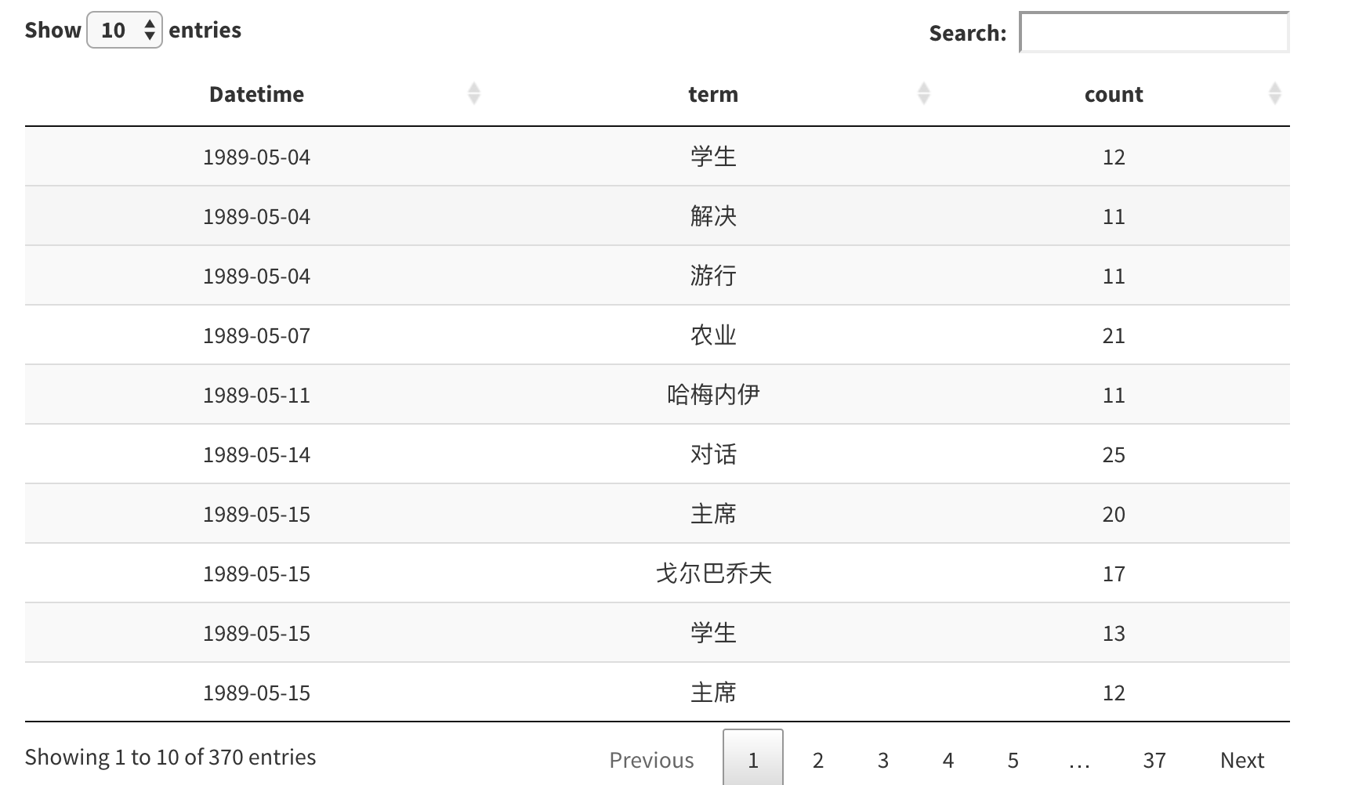

Figure 1. The interactive table presents counts of terms in the front page of People’s Daily on each day from May 4, 1989 (one month before military repression of the movement) to July 3, 1989 (one month after military repression of the movement). This table may help get some sense of the terms that appear in the People’s Daily at that period of time.

With the data at hand, I embark on exploring the official discourse by using three distinct computational methods: first, I analyzed the change of topic models for official discourses before and after the social movements occurring in 1986 and 1989; second, the word frequency changes in the following year of each movement were examined by the binominal regression analysis; third, according to Zhao’s theory of the legitimacy transformation (Zhao, 2000), certain political terms were subsequently sub-categorized and analyzed diachronically. In this preliminary research paper, I will detail the methods, summarize my initial results and the basic implications. Because my study is still under an immature stage, each section only explores the data from a specific perspective, and thus there will not be a coherent story or definite conclusion drawn from this data.

Topic Modeling

In text mining, Latent Dirichlet allocation (LDA) is a particularly popular method for fitting a topic model. It treats each document as a mixture of topics, and each topic as a mixture of words. This allows documents to “overlap” each other in terms of content, rather than being separated into discrete groups, in a way that mirrors typical use of natural language. In this section, I take Tiananmen Square Movement in 1989 as an example and examine shifts in topics before and after the repression of social movements by deploying the LDA method.

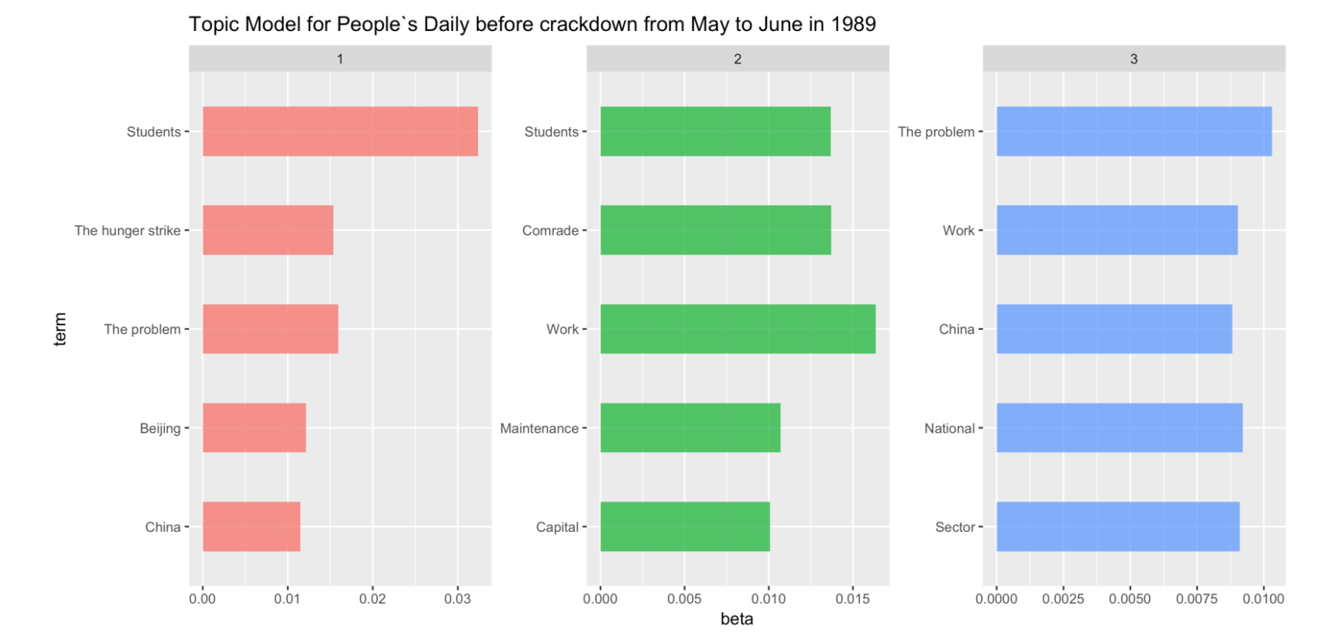

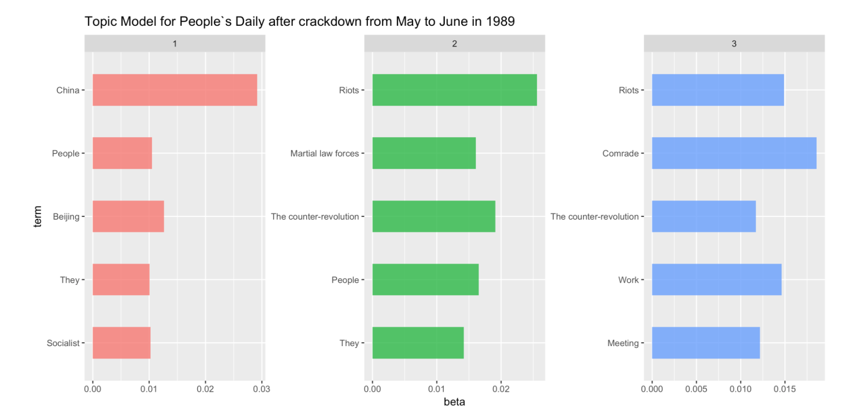

Figure 2. LDA modeling for the official discourses before and after crackdown of the Tiananmen Square Movement in 1989.

According to the LDA modeling (Figure 2) as well as the term frequency analysis (Figure 3), in the *People’s Daily*, before the intensive military repression of the movement, or so-called “crackdown” on June 4, 1989, terms such as students, work, and the problem appear more frequently, which may indicate a certain tolerance of government towards the students who staged the demonstration. However, after the crackdown, the People’s Daily changed its tone abruptly. It frequently used terms such as counter-revolution and riots, which may suggest its intent to disdain the movement.

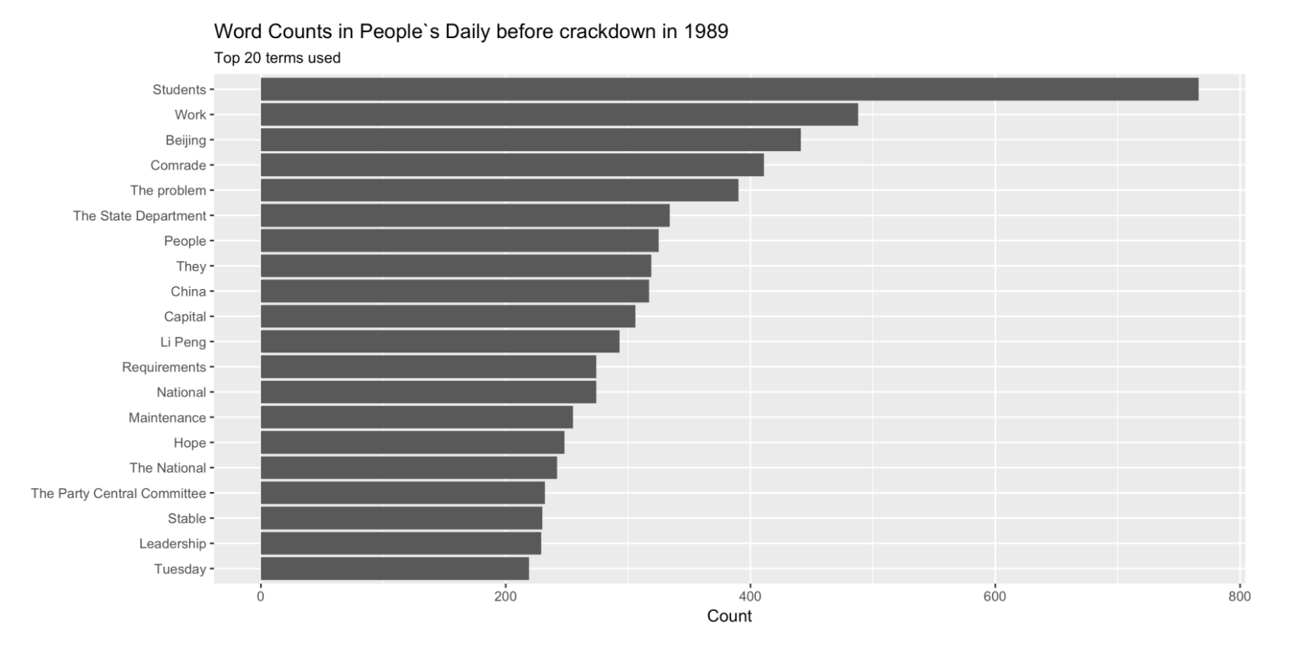

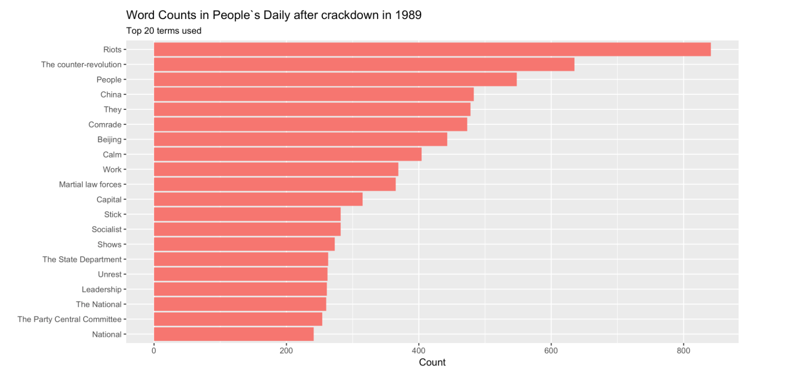

Figure 3. Word frequency count in the *People’s Daily* before and after crackdown in 1989.

Binomial Statistical Analysis of Word Frequency Change

Here I conduct binomial statistical analysis to trace changes of frequency of key terms during 12 months after the repression for both movements. In both graphs as follow, dots represent distinct terms, x-axis represents the change of appearance probability of given terms over 12 months. Positive numbers mark increases in frequency. Y-axis marks the p-value of frequency change. To be clear, I only present 50 terms whose extents of frequency change are the most among all words, and changes for all these selected terms are significant at the .05 level.

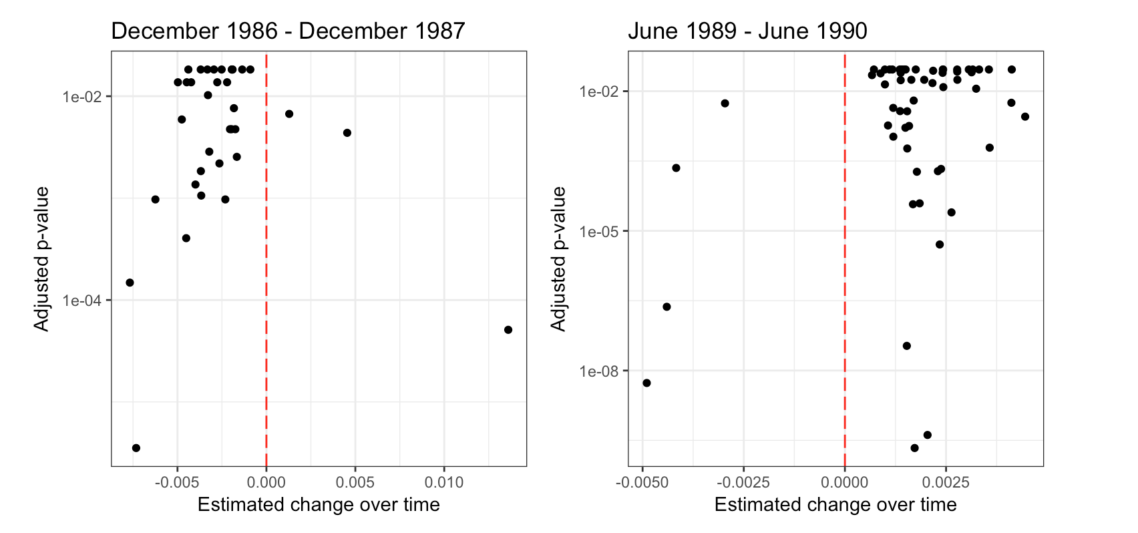

Figure 4. Frequency change with its corresponding *p*-value for the terms appearing in the *People’s Daily* at the following year of two social movements in 1986 and 1989.

These graphs (Figure 4) present interesting findings. During 12 months after the military repression of the 1986 Student Demonstration, most of these significant terms experience an increase in frequency. However, for the case of Tiananmen Square Protest in 1989, the opposite trend is observed. Most of the key terms experience a decrease in word frequency. This suggests that there are denser discourses immediately following the 1989 movement, while the opposite is the case for the 1986 Student Demonstration. In the following two tables (Table 1 and 2), I show those terms that change most abruptly after the repression for both events.

Table 1: Terms whose frequency change most abruptly after the social movement of 1986 on the *People’s Daily*. (Note: “XIII” in the table 1 means the 13th National Congress of the Communist Party of China, which was held during October 25 to November 1, 1987).

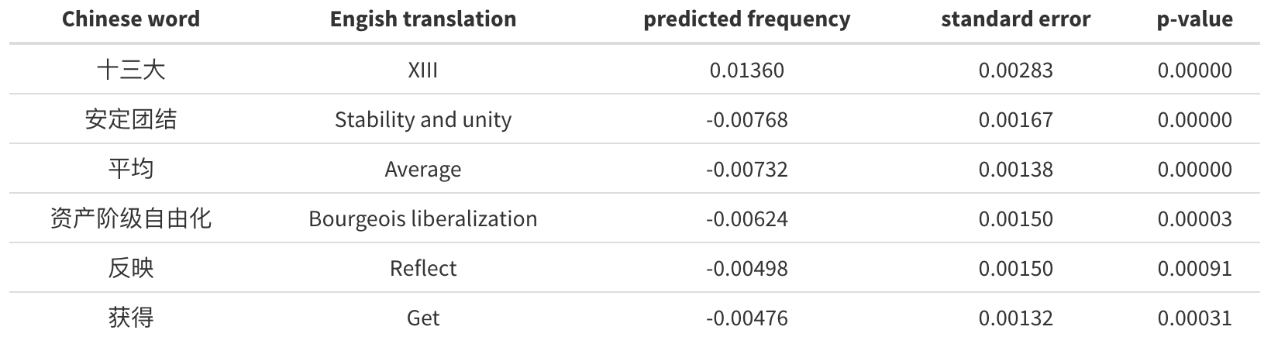

Table 2: Terms whose frequency change most abruptly after the social movement of 1989 on the *People’s Daily*.

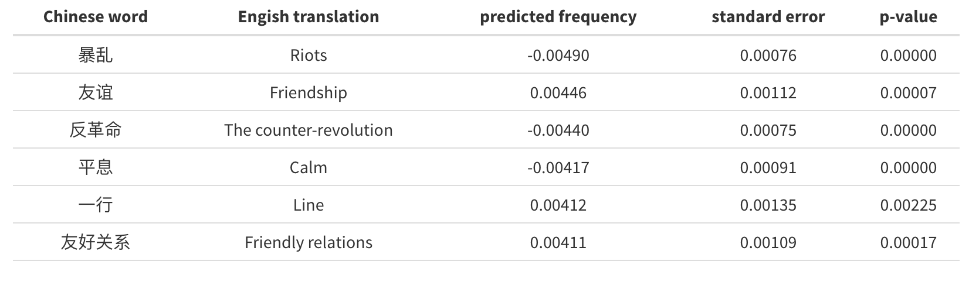

Furthermore, I also plot the top six terms with greatest estimated frequency change in 1986 and 1989 respectively, as shown below in Figure 5 and 6.

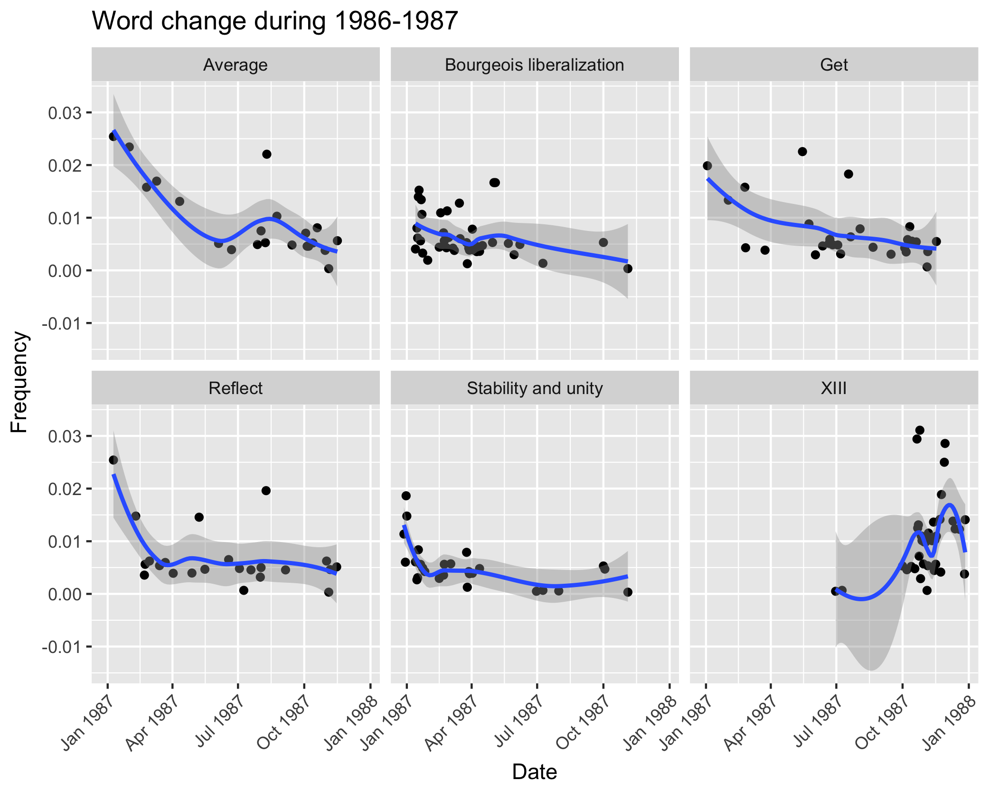

Figure 5: Frequency change of the six top words during 1986-1987 in *People’s Daily*.



Figure 6: Frequency change of the six top words during 1989-1990 in *People’s Daily*.

Theory-based Data Analysis

To track patterns of word frequency change in this newspaper, I group all terms in the *People’s Daily* into three subcategories, following a Weberian conceptual fashion. First, I create a subcategory named strong ideology, containing all terms related to ideologies and counter-ideologies of socialism, including socialism, capitalism, proletariatism, bourgeois liberalism, revolution etc. This subcategory broadly corresponds to traditional authority in Weberian terms. Second, a subcategory of weak ideology is generated as well, including terms containing rationalist-legalist implications in Weberian sense. This subcategory contains words such as reform, stability, stability and unity, etc; Lastly, I generate a subcategory named economic performance and include in it those key terms relevant to economic performance, such as economy construction, economic prosperity, etc. The following graph (Figure 7) depicting change of percentages of terms in each subcategory on a monthly basis in reports on the front page of the *People’s Daily*.

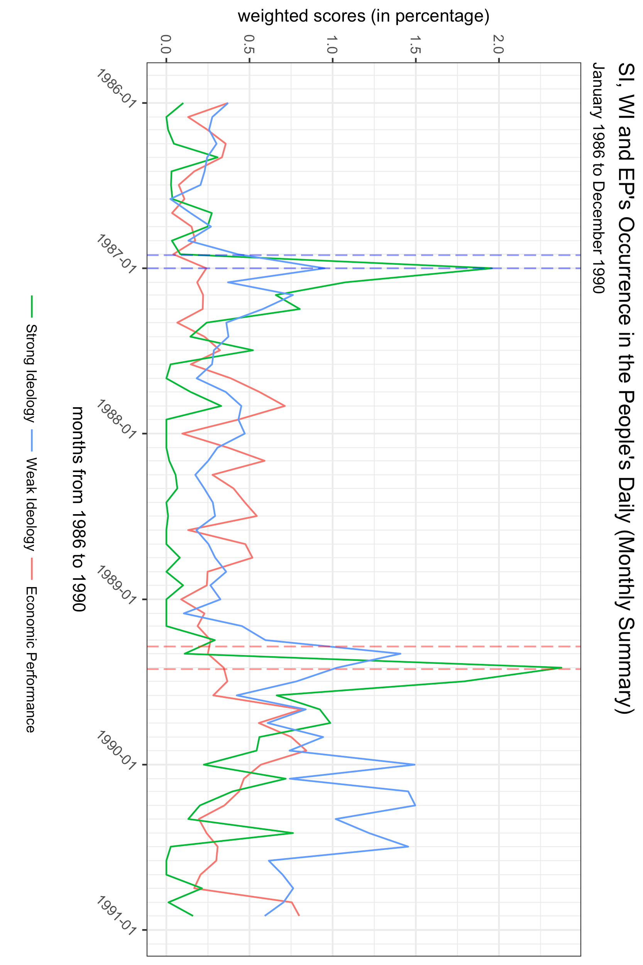

Figure 7: The occurrence of terms sub-categorized as strong ideology (SI), weak ideology (WI) and economic performance (EP) in *People’s Daily* during 1986 to 1991.

My empirical findings indicate that discourses of Chinese authoritarian government did change in the 1980s when multiple social movements emerged and fell. To be more specific, discourses with strong ideology reached its peak when the 1986 Student Demonstration and the Tiananmen Square Protest in 1989 were repressed and then declined, and discourses with weak ideology and characteristics of economic performance gradually increased over the 1980s. These findings provide empirical support for Zhao (2000)’s theory of authoritarian legitimacy. Like Zhao, I agree that the Chinese state use more economy-oriented and rationalist-legalist discourses after the Tiananmen Square Protest in 1989 rather than after the 1986 Student Demonstration. This suggests that when later movements emerged in the 1980s the authoritarian regime may deploy more diverse discourses to distract public attention rather than attempt to draw on discourses with strong ideology to force the public to show commitment to communist ideology. These findings may advance current understanding of authoritarian state’s response strategies for emerging social movements.

Finally, I provide a brief reflection on the relationship between the content of the People’s Daily, the official communist party newspaper, and the authoritarian government of China in the 1980s. It has been well received that content of this newspaper reflected the decisions and wills of the authoritarian state, so we treat the content of the newspaper as discourses of authoritarian government. However, it should be noted that the decisions and wills of the authoritarian state were not shaped by the government *per se*, but also the result of interactions between the state and the society. As demonstrated by the movement events in the 1980s, the discourses did change over time, due to the recurrent interactions between the state and the general public within multiple emerging social movements. Therefore, I advocate that further research should shed more light on the media-state relations in authoritarian contexts.

References

He, Shaoda, Xiaojun Zou, Liumingjing Xiao, and Junfeng Hu. "Construction of Diachronic Ontologies from People's Daily of Fifty Years." In LREC, pp. 3258-3263. 2014.

Tan, Frank. "The People's Daily: Politics and Popular Will-Journalistic Defiance in China During the Spring of 1989." Pacific Affairs (1990): 151-169.

Wu, Guoguang. "Command communication: The politics of editorial formulation in the People's Daily." The China Quarterly 137 (1994): 194-211.

Zhao, Dingxin. 2000. “State-Society Relations and Discourses and Activities of the 1989 Beijing Student Movement.” American Journal of Sociology 105: 1592-1632.